Courage January | 2017

Sunday | Monday | Tuesday | Wednesday | Thursday | Friday | Saturday
1 New Years’ Day Solemnity of Mary, Mother of God | 2 | 3  Quote of the month: Do not be afraid, I am with you.” (Isaiah 41:10) | 4 | 5 | 6 | 7
Epiphany of the Lord 8 | 9 | 10 | 11 | 12 | 13 | 14
 | Think of a historical event or the achievements of people like Gandhi, Mother Teresa, or Martin Luther King, who acted bravely and ethically. | Think about how you can show Courage in 2017 by demonstrating love for, our neighbour. | Do you think Mary and Joseph needed Courage when baby Jesus was born? | Show Courage by standing up for what is right! | Can you think of a time Jesus needed Courage? | “Courage is simply the willingness to be afraid and act anyway.”  Dr. Robert Anthony
15 | 16 | 17 | 18 | 19 | 20 | 21
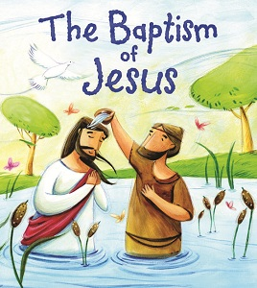 | Know that sometimes doing the right thing is very tough but with Courage you CAN do the right thing. | Draw a picture of someone who is Courageous. | How is the story of the Good Samaritan an example of Courage?  (Luke 10: 30-35) | It takes quite a bit of Courage to admit when we are wrong. Is there anything we need to admit or ask forgiveness for? | What happens when we lose Courage in God?  (Matthew 14:25-33) | Encourage him to raise money for children from very poor or war-ravaged countries, and explain how these kids show Courage just by surviving.
22 | 23 | 24 | 25 | 26 | 27 | 28
Lord Grant me the serenity to accept the things I cannot change, the Courage to change the things I can.  St. Francis of Assisi | How can you use the internet to teach Courage? | Does it take Courage to walk away from a fight or not have an argument? | Write a story about someone you know who demonstrated Courage. | Stand up respectfully when you see something wrong that is being done. | Have faith in God and face your fears with great Courage. | Ask older relatives to tell stories of heroic acts they were part of or witnessed.
29 | 30 | 31
“Have I not commanded you? Be strong and of good Courage; be not frightened, neither be dismayed; for the Lord your God is with you wherever you go.” (Joshua 1:9) | Try something that challenges you physically or mentally. | Courage does not mean taking unnecessary chances or neglecting safety. | Share a story of an experience of Courage, one that allowed you to feel like a different person.

